Name:
Khan Muhamamd Bilal
Roll-No:
2024-CET-20
Department:
Software Engineering
Group:
Computer Engineering Technology
Semester:
4th Semester
Subject:
Graphic Designing
Lab Task:
Exploring Canva Interface & Designing a Motivational Quote Post
Submitted To:
Madam Fatima
Lab Topic: Exploring Canva Interface & Designing a Motivational Quote Post

Instructions
Explore the Canva design platform (www.canva.com). After exploring the interface, answer the following questions and complete the design task.

Task 1: Canva Interface Exploration
Q1. Name any FOUR tools available in the Canva sidebar.
1.Templates
2.Elements
3.Text
4.Uploads

Q2. What is the purpose of the following Canva tools?
Canva Tool | Purpose
Elements | This tool contains elements for our design like stickers, shapes, and mockups.
Text | This tool contains different types of text styles, heading, and text boxes for our design.
Uploads | With this tool we can upload different types of material like images, and videos for our design from device.
Task 2: Design Task Motivational Quote Post
Create a motivational quote post of your own choice using Canva.
- Design Requirements:
- Canvas Size: 1080px × 1080px
- Background color or image
- Motivational quote text
- Decorative shapes or icons

Our Design
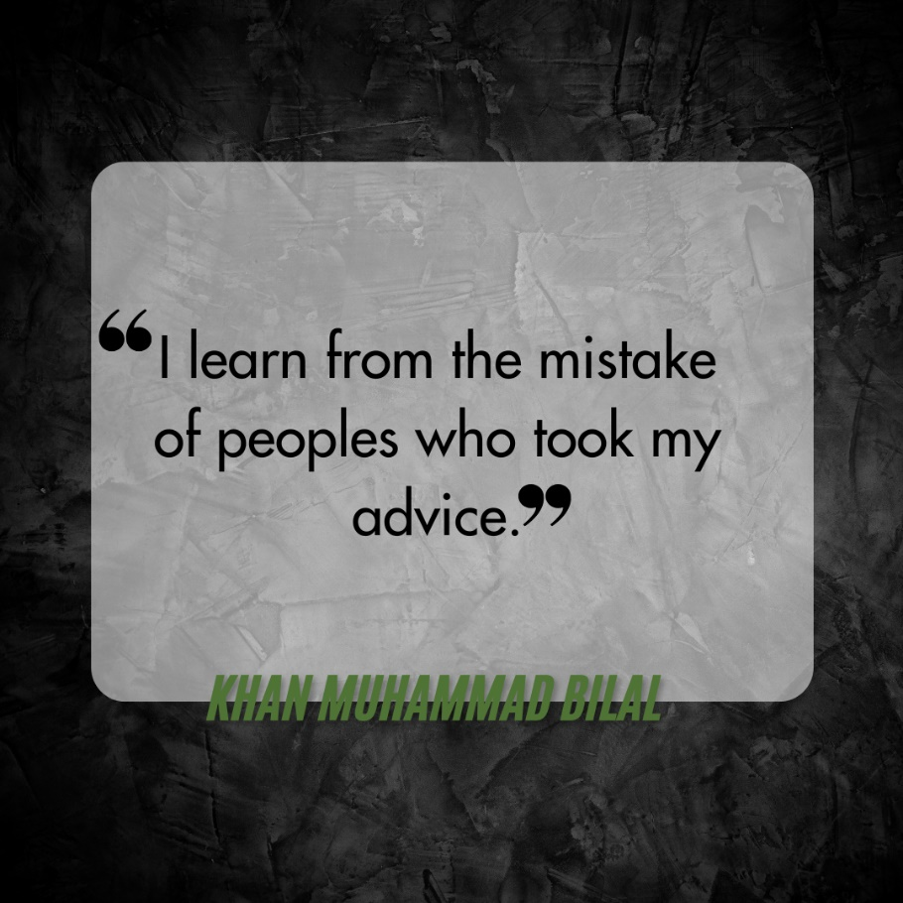

Instructor Evaluation Rubric (10 Marks)
Criteria | Marks
Canva interface exploration | 3
Understanding of Canva tools | 2
Motivational quote design | 3
Creativity and layout | 2

